Exercise 1
Configure your environment so you can use the AWS CLI. When the CLI is configured run the following commands:
$ wget https://2tin-cloudessentials-resources.github.io/cloud-essentials-labs/debuglabs/2_1.yml -outFile 2_1.yml
$ aws cloudformation deploy --template-file ./2_1.yml --stack-name ch2ex1Copy to clipboardErrorCopied
Note: These commands work in Powershell, for Linux you might have to change wget options.
Using the AWS management console or CLI, try answering the following questions:
- What are the names of the 2 instances created?
InstA en InstB
- What is the name of the AMI that is used for both instances?
amzn2-ami-kernel-5.10-hvm-2.0.20240412.0-x86_64-gp2
- What is the instance type for both machines?
t2.large en t2.micro
- What is the public IPv4 address for InstA?
35.168.16.8
- What is the private IPv4 address for InstB?
10.0.1.41
- What is the name for the keypair linked to both machines?
Exc1
- Search for a linked security group. What is the name of this group?
ec2 incomming http
sg-00b6628322d5ae717 (ec2 incomming http)
- What rules are present in this security group?
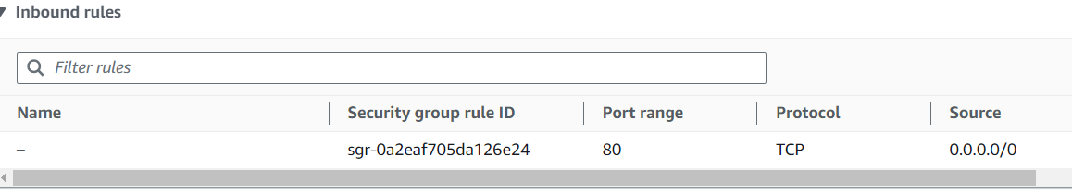
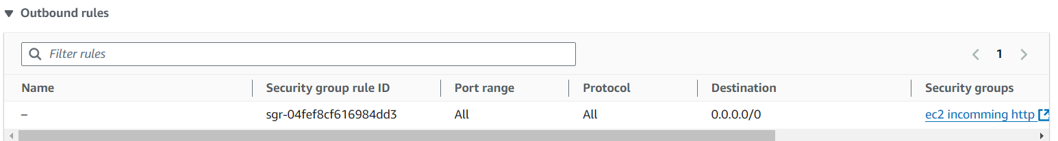
- Our customer is complaining that the costs for his EC2 instances are expensive. What causes this issue and how would you fix this?
When you are done you can run the command below to destroy resources used by this exercise:
aws cloudformation delete-stack --stack-name ch2ex1

Oefening 2
Configureer uw omgeving zodat u de AWS CLI kunt gebruiken. Wanneer de CLI is geconfigureerd, voert u de volgende opdracht uit:
$ wget https://2tin-cloudessentials-resources.github.io/cloud-essentials-labs/debuglabs/2_2.yml -outFile 2_2.yml
$ aws cloudformation deploy --template-file ./2_2.yml --stack-name ch2ex2
A) De bovenstaande opdrachten zetten een EC2-instance op met de naam "imbroken". De instance gebruikt een UserData-script om een ​​standaardwebserver te installeren, maar er ging iets mis. Probeer met behulp van de cloud-init status opdracht en cloud-init-output.log het bestand te achterhalen wat er mis is gegaan. U kunt de gebruiken vockey om verbinding te maken met de instance.
B) Probeer met behulp van deze documentatiepagina het probleem op te lossen en start de webserver. U zou een webpagina moeten kunnen zien wanneer u het openbare IP-adres van het exemplaar bezoekt.
Wanneer u klaar bent, kunt u de onderstaande opdracht uitvoeren om de bronnen te vernietigen die door deze oefening worden gebruikt:
aws cloudformation delete-stack --stack-name ch2ex2
Oef2
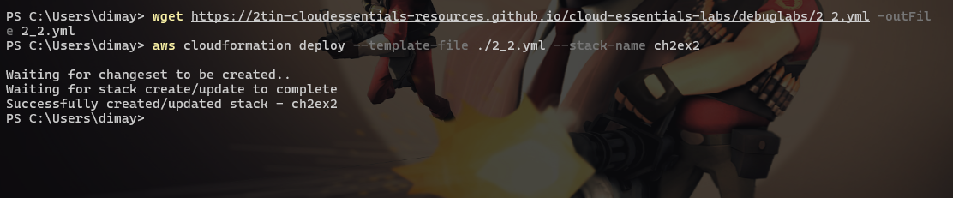
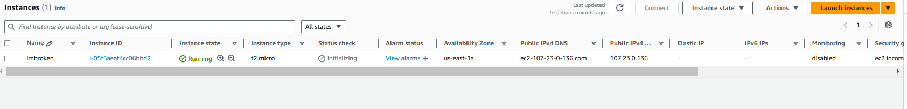
Ssh ec2-user@107.23.0.136 -I C:\Users\dimay\.aws\labuser.pem

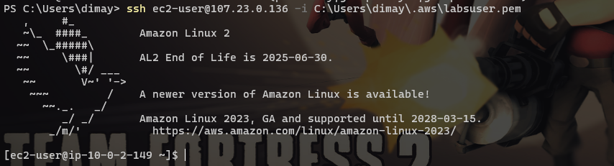
Sudo cloud-nit status
Sudo yum update -y
Sudo yum install -y httpd php php-mysqli mariadb105
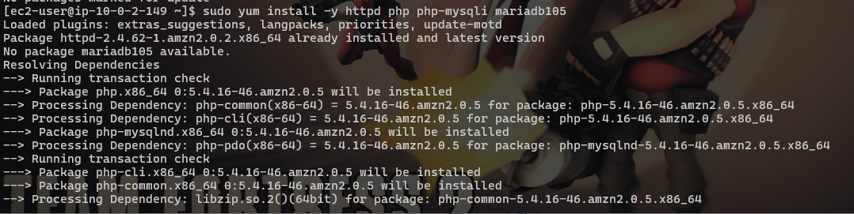
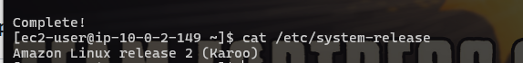
Sudo systemctl start httpd
Sudo systemctl enable httpd
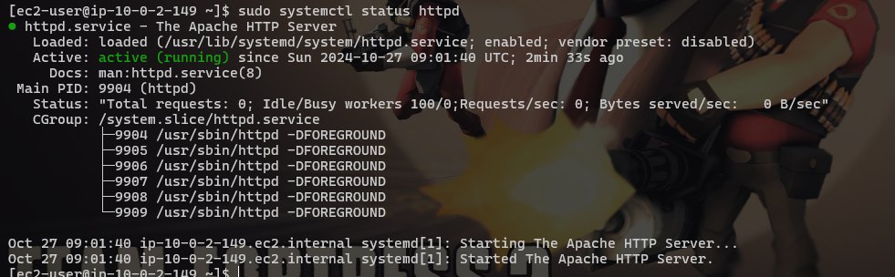
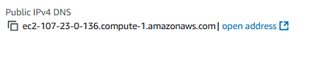
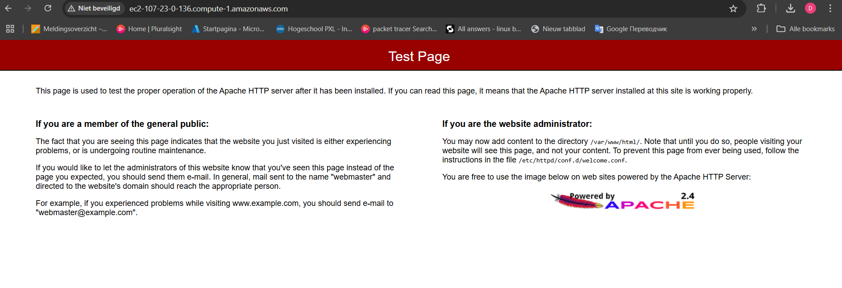
Oef3
Create a new t2.micro instance using the Amazon linux AMI. Use a userdata script that automaticly installs docker on the machine.
Connect to the machine and run the docker ps command to verify the installation is succesful. Try running the Docker hello world example.

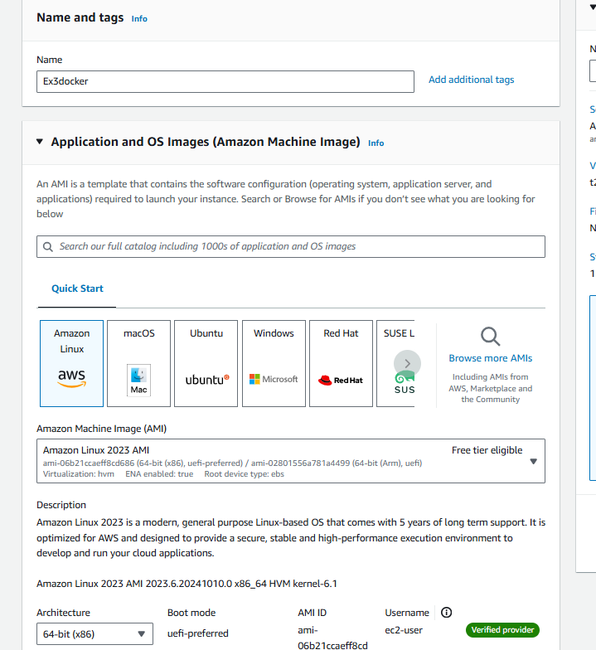
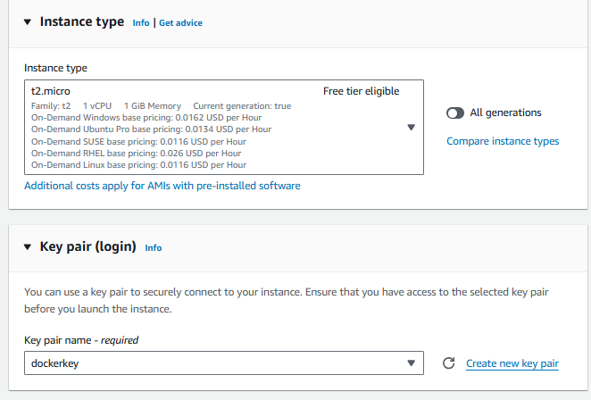
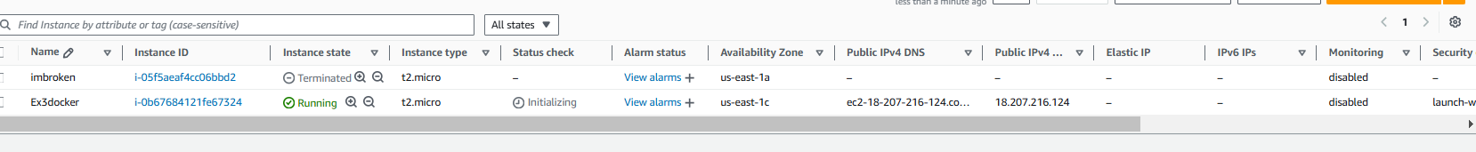
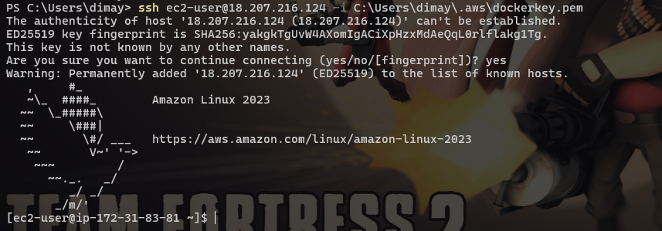
sudo yum install docker
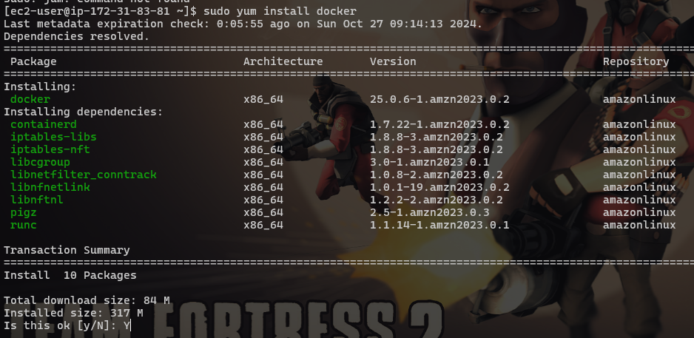
sudo service docker start
sudo docker ps
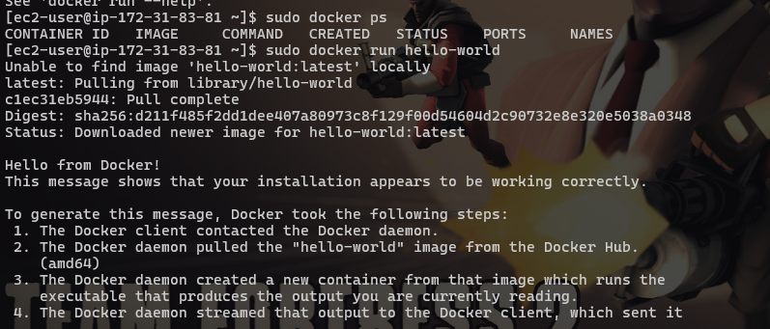sudo service docker status
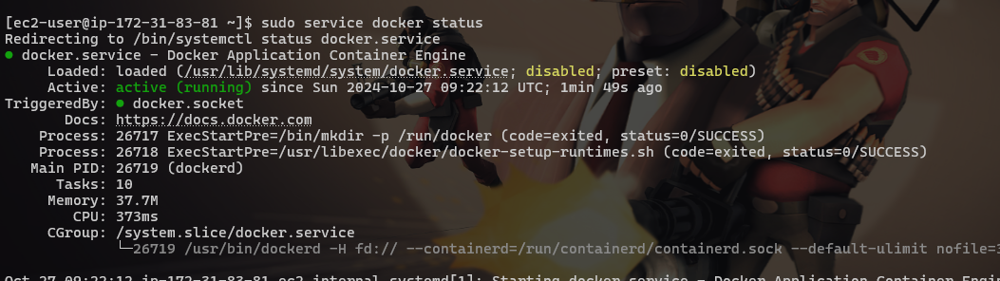

Oef4
With EULA=TRUE
